Existing SecRel.Exe Screens

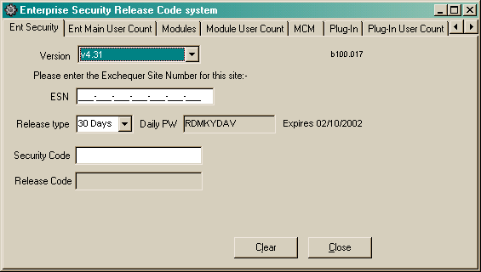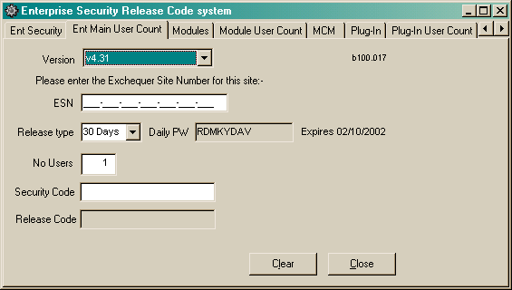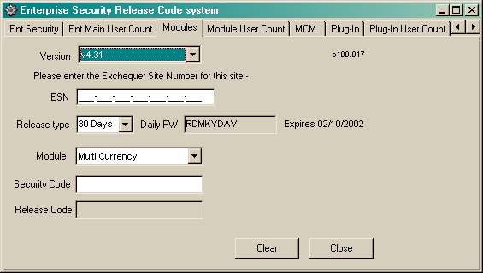

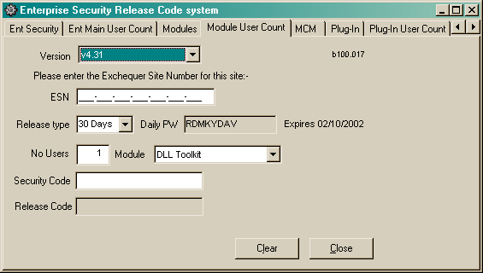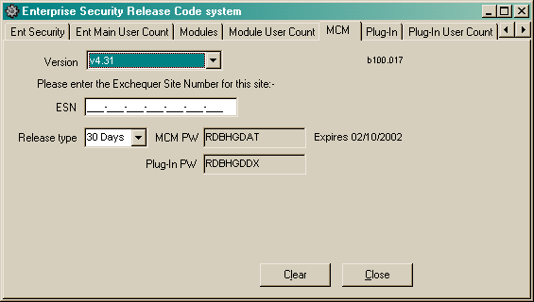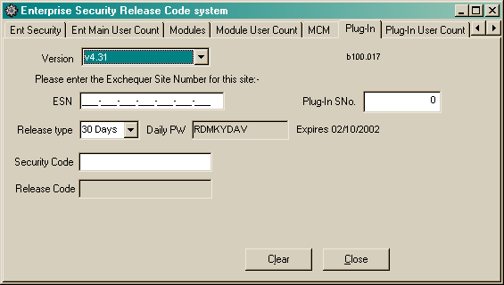

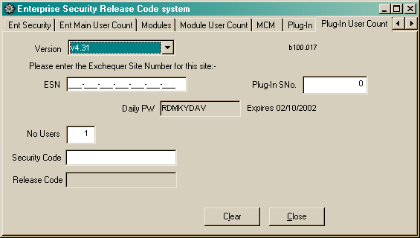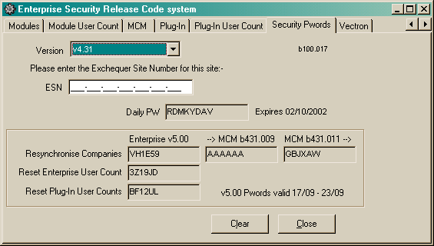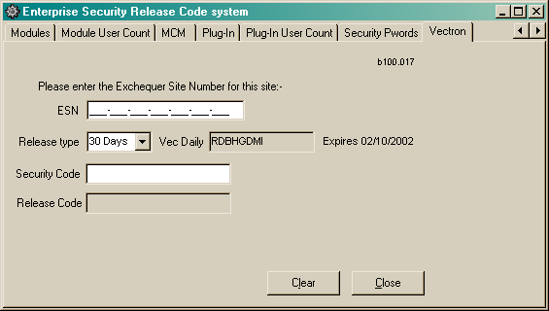

SecRel Site Map Proposal

Login

Customer Details

Release Codes
Register Customer

Login
The entry point to the web-site will be the login screen, users should not be able to jump into any other page within the SecRel web-site.

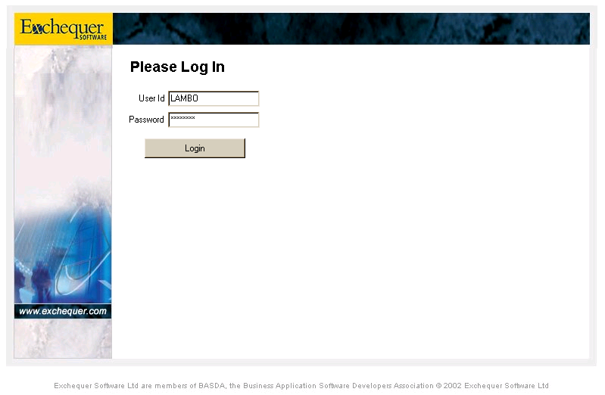

Security access is controlled using a modification of the Exchequer Security Database (see separate document) which also records the dealer or distributor for ease of maintenance and reporting:-

Users
Database of user details

User Permissions
Permissions xref for a specific User and Security Element

Security Elements
Program elements that have security
*
*

*
*

Security Groups
Categories for organising the maintenance of the Security Elements

Dealers

Each CustomerSite, Dealer and User within the database will also have a suspended flag which allows us to suspend their usage of the web-site. If the Dealer is suspended then this will suspend all their users as well.

The Dealers/Users/UserPermissions tables are maintained internally within Exchequer Software. It may be possible to setup some sort of import facility to make life easier for the administrator.

Each Dealership will have the generic part of the email address stored against it, e.g. ComTek.Com, and each User will have an email address, if that email address doesn’t match the dealers generic portion then an on-screen warning will be displayed as we don’t want to support personal HotMail, FreeServe, etc… accounts.

Each user will also be able to register a mobile phone number so that they can be notified of release codes via SMS. This will be useful when on-site as the email would typically go to their PC at the office. NOTE: This may not be available for some overseas personell.

Users will have randomly generated passwords that change periodically to prevent unauthorised usage. When the password is changed an email will be sent to the users to notify them of the new password. A ‘Forgotten Password’ option can be given that generates a new password and emails it to the user, this will work by email address rather than User Id.

Customer Details
After successfully logging in the Customer Details window will be displayed. This page works in two different ways depending on the users rights:-

- For Dealers it will allow them to select the customer site that they want to generate release codes for.

- For Exchequer Internal Staff and Distributors it will allow the Dealership to be selected and then the customer site for that dealership (this needs more thought before being finalised):-

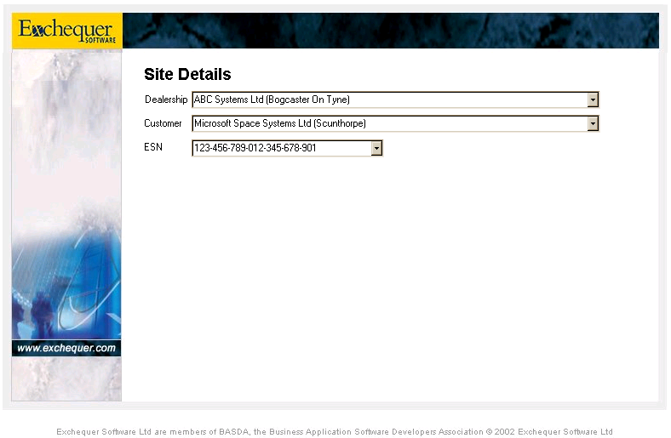

Once the site has been selected then the Release Code screen will be displayed.

A facility will be made available to allow new sites to be added at this point, details will be:-

Distributor Exch UK/NZ/EIRE/Aus, LanPro, etc…
Dealership Omega, Comtek, …
CompanyName ABC Systems Ltd (Bournemouth)
ESN 100-100-100-100-100-100-999

Minimal information should be kept on the site to avoid redundant duplication, any changes to this information must be done manually by ExchUK staff.

These details may be kept up to date using an email update system from the CD Licence Generator, this would require the web-server to have an email server installed with its own email addresses.

Release Code Page
Once the site has been selected then the next page will allow release codes and passwords to be acquired. There are effectively going to be two different versions of this page, one for internal staff and one for Dealers/Distributors:-

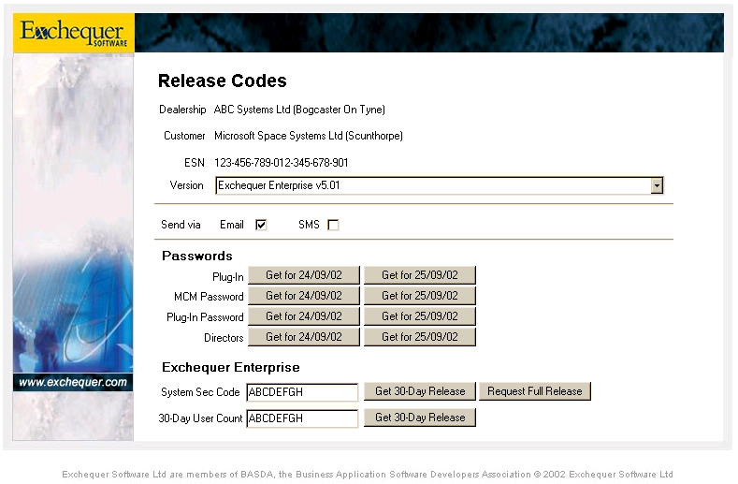
This section hidden for Internal Staff Version.
Buttons replaced with edit boxes for Internal Staff Version.

A security option will allow all buttons to be Request if required.

Internal Staff Version
This Internal Staff Version provides full access to all release codes and displays the results on screen.

Some additional form of security would be required to prevent this version being used on machines outside the building. Maybe some sort of cookie and if the cookie isn’t present they get the DDV version detailed below.

This would mean that within the building Des/Dave would get the internal version with on-screen release codes, whilst on-site they would get the dealer version with email/sms notification, all under the same User Id/Pword.

From this page links to other pages can be added for supporting Module Release Codes, User Release Codes, Plug-In Release Codes, etc…

Dealer/Distributor Version
The Dealer/Distributor Version provides access to a limited selection of release codes and only supports sending the results via Email or SMS, no onscreen display is supported for security reasons.

This version is limited to providing release codes for:-

Enterprise 30-Day System
Enterprise 30-Day User Counts
Toolkit 30-Day Runtime Module
Toolkit 30-Day User Counts

It will also provide the following passwords:-

Plug-In Password
MCM Password
Daily System Passwords
Enterprise Directory Daily Password
Reset Enterprise User Counts

NOTE: Some of these might be better placed in the following category and require an explanatory description in the request.

Additionally the following codes can be requested, which will send an email into Exch UK for authorisation:-

Resynchronise Companies (*)
Full Enterprise System

( * Description Required )

Also if the users request Full release codes then, depending on their security settings, they may need to be authorised by ExchUK before they are released.

In this case the request, containing various details including the release codes, would be emailed to a nominated staff member within Exchequer Software UK for approval. If OK then the email would be forwarded to the required destination. Obviously this system cannot support SMS.

When a Resynchronise Companies request is sent out the ESN within the Customer details will be reset (000-000-000-000-000-000-000) and the next time in it will have to be set before they can pass the Customer Details page. If the ESN is not confirmed manually via email then it will expire after 7 days for security reasons and the customer will be suspended.

Limited Releases
For each Release Code/Password type there will be a security record keeping track of how many releases of have been given to the customer. The purpose of this is to prevent a dealer giving a customer a new 30-Day system release code every month, only a certain number of codes would be allowed within a given period, e.g. 1 per 60 days.

For internal staff there will be an override flag within the security flags to allow them to override the warning and give the code anyway. There should be one flag per release code to allow junior staff to override minor items but not major items.

Alert Reporting
It may be nice to send email alerts to internal Exch UK staff when certain events occur, such as a Release Code Limitation being reached.

Maintenance Utilities
Various utilities are going to be required for setting up dealers and their users as well as maintaining the customer details. There are three ways this can be done:-

- Add additional web-pages onto the site for use by internal Exch UK staff.

- Write standalone windows apps running on the same server.

- Write standalone windows apps running on local workstations that update the server via email using XML format files (?).

Email Updating
This is the preferred option as it allows the updates to be done automatically from other programs such as the CD Licence Generator without any user intervention.

This system would require an email system such as FTGate to be running on the server and processing emails for a new domain, e.g. ExchequerRelease.Com.

Emails sent to the site would have encrypted XML attachments that contain Dealer Details, User Details, Security Details, Customer Details etc…

Audit Trail
Every significant action on the site from the initial Login to requesting release codes will be noted in the Audit Trail, this will be a SQL database that can be used for reporting to identify problem sites/dealers/user or trends.

The following details will be needed:-

Dealership
UserId
CustomerSite
DateTimeStamp
TextDescription of action

The easiest way to analyse the data would probably be Crystal Reports through ODBC.

ToDo: Identify how internal staff can access the database from their PC’s as it is stored on a standalone PC completely unconnected to the network.

Database Notes

*
*

Audit Trail
*
*
Dealers
Customers
ReleaseCodes
*

*
?

*
Master ReleaseCodes
Customer ESN’s

Audit Trail
This table stores the details of what has happened in the system, see the Audit Trail section for more details.

Customers
This table stores the customer details:-

CustomerCode : String [10]
Unique code identifying the customer.

DealerCode : String[10]
This is the code of the Dealer or Distributor responsible for supporting the site.

CustomerName : String[60]
This is the display name for the customer.

CustomerESN : Array [1..7] of Byte
This is the last registered ESN for the customer, this may be moved out to the separate Customer ESN’s table.

Customer ESN’s
This table stores ESN’s for a customer which may or may not be required.

Dealers
This table will contain the details of the Dealers and Distributors:-

DealerCode : String[10]
This is a Unique Id Code for relational links

DealerParent : String[10]
This identifies the DealerCode of the dealers parent distributor, for example this would be ExchUK for ComTek. This field is used on the Customer Details page to control which dealers are listed in the Dealer Combo. It must be set if DealerType=dtDealer and can only be set to a DealerCode whose DealerType = dtDistributor or dtHeadOffice, it is not available for types dtDistributor or dtHeadOffice.

DealerName : String[60]
This is the Dealers Description, e.g. ‘Exchequer Software UK Ltd’.

DealerType : Enum
This type identifies whether the dealer details apply to a dealer, distributor or Exchequer UK itself:-

dtDealer (default)
This Id indicates that its just a normal dealership.

dtDistributor
This Id indicates that the dealer is actually a distributor. This means that all dealers with this code as its parent will be listed in the dealer combo on the customer details page (plus itself of course!).

dtHeadOffice
This Id indicates that it is Exchequer Software UK which provides various privileges within the system. One of these features is that ALL dealers will be listed in the dealer combo on the customer details page.

DealerEnabled : Boolean
This flag allows the Dealer and all its users to be suspended.

Master ReleaseCodes
This table contains the master rules for how many times each release code can be given within a specified period, e.g. Can be used once every 60 days, can be used 4 times / year, etc…

NOTE: This area needs some serious designing

ReleaseCodes
This table keeps track of how many times each ReleaseCode has been given and is used to determine whether release codes can be given.

NOTE: This area needs some serious designing

